School Logo

# [School Name]

**Title I School-Level Parent and Family Engagement Policy [Current Year]**

***[School Name]*** has developed a written Title I parent and family engagement policy with input from Title I parents and agreed upon by Title I parents. ***[Describe how the school developed the policy with parent input and how/when parents agreed with the policy. Describe how parents are notified of the policy in an understandable and uniform format and, to the extent possible, in a language parents understand.]***

This policy describes the means for carrying out the following Title I parent and family requirements:

**Section I: Involvement of Parents in the Title I Program**

To involve parents in the Title I program at ***[School Name]***. the following practices have been established:

* The school convenes an annual meeting, at a convenient time, inviting all parents and family members of Title I students, informing them about Title I requirements, the school’s involvement in the program, and about the right of parents to be involved in the Title I program. ***[Briefly describe or bullet how this happens at your school.]***
* The school offers a flexible number of meetings for Title I parents, such as meetings in the morning, afternoon, or evening. ***[Briefly describe or bullet how this happens at your school.]***
* The school involves parents of Title I students in an organized, ongoing, and timely way, in the planning, review, and improvement of the school’s Title I programs, including the planning, review and improvement of the school’s Title I parent and family engagement policy and the joint development of the School Plan for Student Achievement. ***[Briefly describe or bullet how this happens at your school.]***
* The school provides parents of Title I students with timely information about Title I programs. ***[Briefly describe or bullet how this happens at your school.]***
* The school provides parents of Title I students with a description and an explanation of the curriculum used at the school, the academic assessments

used to measure student progress, and the achievement levels students are expected to meet with the state standards. ***[Briefly describe or bullet how this happens at your school.]***

* If requested by parents of Title I students, the school provides opportunities for regular meetings to formulate suggestions and to participate in decisions relating to the education of their children, and to respond to any such suggestions as soon as possible. ***[Briefly describe or bullet how this happens at your school.]***
* If the School Plan for Student Achievement is not satisfactory to Title I parents, parent comments can be submitted on the plan. ***[Briefly describe how parents can submit comments on why the plan is unsatisfactory.]***

**Section II: Building Capacity for Involvement**

***[School Name]*** engages Title I parents and family members in meaningful interactions with the school to ensure effective involvement of parents and to support a partnership among the school to improve student achievement. It supports a partnership among staff, parents, and the community to improve student academic achievement. To help reach these goals, the school has established the following practices:

* The school provides Title I parents with assistance in understanding the State’s academic content standards, state and local academic assessments, and how to monitor a child’s progress and work with

educators to improve the achievement of their children. ***[Briefly describe or bullet how this happens at your school.]***

* The school provides Title I parents and family members with materials and training to help them work with their children to improve their children’s achievement, paying special attention to support for foster parents. ***[Briefly describe or bullet how this happens at your school.]***
* *With the assistance of Title I parents, the school educates teachers, specialized instructional support personnel, assistant principals and other school leaders, and other staff about the value and utility of the contributions of parents and family members, and about how to reach out to, and communicate with, and work with parents as equal partners to build ties between parents and the school.*

***[Briefly describe or bullet how this happens at your school.]***

* The school coordinates and integrates the Title I parent and family engagement program with other programs, and conducts other activities, such as Parent and Family Centers, to encourage and support parents in more fully participating in the education of their children. ***[Briefly describe or bullet how this happens at your school.]***
* The school distributes information related to school and parent programs, meetings, and other activities to Title I parents and family members in a format and, to the extent practicable, in a language that they understand. ***[Briefly describe or bullet how this happens at your school.]***
* The school provides support for parent and family involvement activities requested by Title I parents. ***[Briefly describe or bullet how this happens at your school.]***

**Section III: Accessibility**

***[School Name]*** provides opportunities, to the extent practicable, for the participation of all Title I parents and family members, including parents and family members with limited English proficiency, parents and family members with disabilities, and parents and family members of migratory students.

Information and school reports are provided in a format and language that parents understand. [***Briefly describe or bullet how this happens at your school.]***

**Section IV: Shared Responsibilities for High Student Academic Achievement**

***[School Name]*** distributes to parents of Title I students a School-Parent Compact. **It is attached to this policy**. The Compact, which has been jointly developed with parents and approved by them, outlines how parents, the entire school staff, and students will share the responsibility for improved student academic achievement. ***[Describe how the school developed the Compact with parent input and how/when parents agreed with the compact. Describe how parents are notified of the compact in an understandable and uniform***

***format and, to the extent possible, in a language parents understand.]***

The Compact describes specific ways the school and families will build and develop a partnership to help children achieve California’s high academic standards. It addresses the following legally required items, as well as other items suggested by parents of Title I students. ***[Briefly describe or bullet how the list of items below happens at your school.]***

* The school’s responsibility to provide high-quality curriculum and instruction in a supportive and effective learning environment that enables children to meet California’s academic standards
* The ways that parents can volunteer in their child’s classroom
* The ways that parents can participate in, as appropriate, in decisions relating to the education of their children and positive use of extracurricular time
* The ways parents will be responsible for supporting their children’s learning
* The importance of ongoing communication between parents and teachers on an ongoing basis through, at a minimum, the following:
  + annual parent-teacher conferences in elementary schools during which the compact shall be discussed as the compact relates to the individual child’s achievement.
  + frequent reports to parents on student progress.
  + reasonable access to staff
  + communication regarding opportunities for parents to volunteer and participate in their child’s class and opportunities to observe classroom activities
  + Ensuring regular two-way, meaningful communication between family members and school staff, and, to the extent possible, in a language that family members can understand.

This policy and compact was adopted by School on

(date) and will be in effect for the entire school year. This policy can be amended each year when ***[Describe how parents can give input to change the policy].*** It has been distributed to all parents on

(date) and is made available to the local community by

***[Describe the means for informing the local community]***. This policy is a companion document to the School Plan for Student Achievement. If there are concerns about the School Plan for Student Achievement, parents can submit their concerns to ***[Name of school principal]****.* The school principal will submit the comments with the School Plan to the Federal and State Education Programs Office for submission to the state.

Lastly, there is a LAUSD Title I Parent and Family Engagement Policy that is sent to parents each year and applies to all parent at Title I schools. It is amended periodically to meet the requirements of the Elementary and Secondary Education Act.______

# School-Parent Compact Guide to Quality and Quality Indicators

|  |  |  |  |  |
| --- | --- | --- | --- | --- |
|  | **Does the school-parent compact:** | | **What section of Title I law does this address?** | **To make the compact most effective?** |
| **S C H O O L**  **R O L E** | Clearly explain district and school goals for students to meet the challenging State academic  standards. | Yes □  No □ | 1118(d) ESEA  1116(d) ESSA | * Link actions in the compact to goals in the school improvement plan. * Use achievement data to set specific goals. |
| Describe ways that teachers are responsible for supporting students’ learning and providing high quality curriculum and instruction. | Yes □  No □ | 1118(d);  1118(d)(1) ESEA  1116(d);  1116(d)(1) ESSA | * Describe the high-quality curriculum the school uses (to support the Common Core State Standards). * Describe how teachers will help parents understand what children are learning and doing in class. * Specify how teachers will support parent participation in learning activities. |
| Provide information and actions specific to each grade level. | Yes □  No □ | This is considered a best practice and is not required under Title I law. | * Include high-impact actions for each grade level designed by grade-level teams with parents. |
| **P A R E N T**  **R O L E** | Describe specific ways parents will be responsible for supporting their children’s learning. | Yes □  No □ | 1118(d);  1118(d)(1) ESEA  1116(d)  1116(d)(1) ESSA | * Connect activities for families to what students are doing in class. |
| Provide information and actions specific to each grade level, tied to the school improvement plan. | Yes □  No □ | This is considered a best practice and is not required under Title I law. | * Include high-impact actions for each grade level or at least primary and elementary grade levels, designed by grade-level teams with parents. |
| **S T U D E N T**  **R O L**  **E** | Describe specific ways students will be responsible for their learning. | Yes □  No □ | 1118(d) ESEA  1116(d) ESSA | * Connects activities for students to what they are doing in class. |
| Provide information and actions specific to each grade level. | Yes □  No □ | This is considered a best practice and is not required under Title I law. | * Include high-impact actions for each grade level or at least primary and elementary grade levels; designed by grade-level teams with parents. |

|  |  |  |  |  |
| --- | --- | --- | --- | --- |
|  | Describe school activities to build partnerships with parents, including chances for parents to volunteer, take part in, and observe classroom activities, and communicate with teachers. | Yes □  No □ | 1118(d);  1118(d)(2) (C) ESEA  1116(d)  1116(d)(2)(C) ESSA | * Provide both parents and teachers opportunities to develop skills for working together (for example, schedule literacy conversations, demonstration lessons, class meetings, workshops; publicize volunteer and leadership opportunities). * Offer activities based on identified parent needs. * Offer meetings at different days and times. |
|  | Describe how parents and family members are involved in developing and revising the compact. | Yes □  No □ | 1118(d);  1118(f) ESEA  1116(d);  1116(f) ESSA | * Provide resources to cover costs for parents to take part, such as childcare and transportation. * Give specifics about how parents are involved (for example, parents participate on data teams that meet to update the compact; annual review by the school governance council, which includes parents). * Schedule meetings at accessible locations and at different days and times. |
|  | Ensure regular two-way meaningful communication between family members and school staff throughout the school year, so that parents are kept up to date on their students’ progress and get regular tips on home learning. | Yes □  No □ | 1118(d)(1);  1118(d)(2)(A and B) ESEA  1116(d)(1);  1116(d)(2)(A-C) ESSA | * Include parent-teacher conferences at least once a year, at which the compact will be discussed. * Include follow-up steps to support parents and students. * Consult with parents on communication strategies that work best for them. * Make communication do-able and user- friendly. |
|  | Communicate information using family language and format. | Yes □  No □ | 1118(f) ESEA  1116(f) ESSA | * Work with parents to identify and eliminate unnecessary jargon and negative language. * Engage parents/staff with design skills to create an attractive final product. * Translate the compact and other   communication into families’ first languages. |

Numbers correspond to sections in the “Sample Planning Tool”. Adapted by the Title I Policy and Program Guidance Office, California Department of Education, with permission from the Connecticut State Department of Education. 2016. *Building Powerful Partnerships with Families: Transforming Your Old Title I School-Parent Compacts into Effective Action Plans. Tool #7C: Guide to Quality-Title I Requirements and Quality Indicators.* Available at [http://www.ctschoolparentcompact.org.](http://www.ctschoolparentcompact.org/)

# Title I School-Parent Compact Template

(brochure structure)

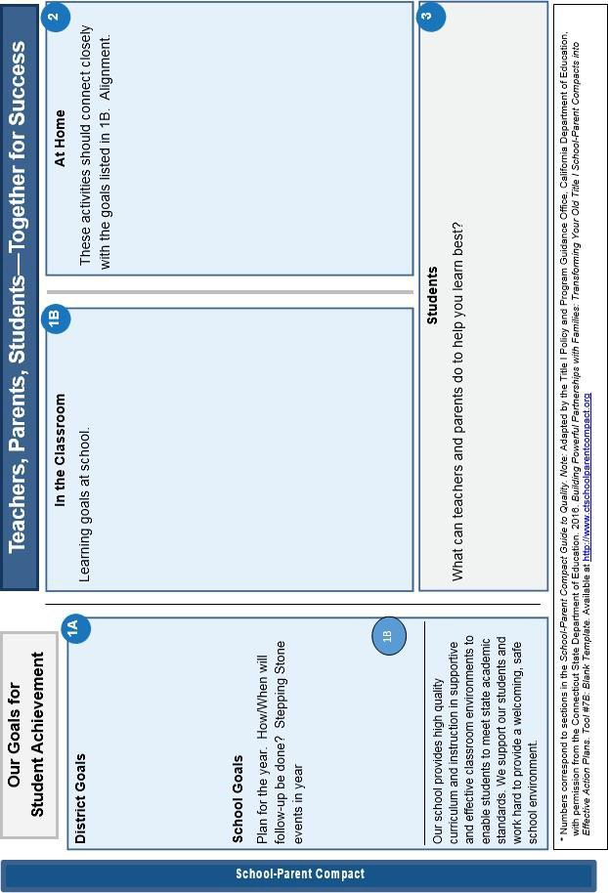

# Title I School-Parent Compact Template

(brochure structure)

